**Project Design Phase-I**

**Solution Architecture**

|  |  |
| --- | --- |
| Date | 15 October 2022 |
| Team ID | PNT2022TMID9823 |
| Project Name | Signs with Smart Connectivity for Better Road Safety |
| Maximum Marks | 4 Marks |

**Solution Architecture:**

In present Systems the road signs and the speed limits are Static. But the road signs can be changed in some cases.

We can consider some cases when there are some road diversions due to heavy traffic or due to accidents then we can change the road signs accordingly if they are digitalized.

This project proposes a system which has digital sign boards on which the signs can be changed dynamically. If there is rainfall then the roads will be slippery and the speed limit would be decreased. Using this we can enter the data of the road diversions, accident prone areas and the information sign boards can be entered through web app. This data is retrieved and displayed on the sign boards accordingly.

* To replace the static signboards, smart connected sign boards are used.
* These smart connected sign boards get the speed limitations from a web app using weather API and update automatically.
* Based on the weather changes the speed may increase or decrease.
* Based on the traffic and fatal situations the diversion signs are displayed.
* Examples -Guide(Schools), Warning and Service(Hospitals, Restaurant) signs are also displayed accordingly.

**Example - Solution Architecture Diagram:**

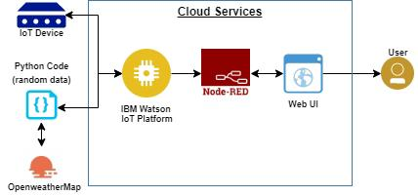

Figure 1: Architecture of Smart Connectivity for Better Road Safety